ICAO: EDFV Callsign: Worms Info Tower / Info: 124.600 EN/GE

Elevation: 295 ft / 90 m Traffic Circuit: S 1300 Ground:

Location: 1.4 NM S Worms QDM: 124.600

FIS: Frankfurt Information 123.325

Flight Rules: NVFR GAFOR: 45

Approach:

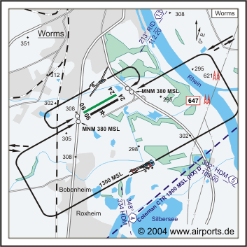

Navigation:

348°/4 NM from HDM 334 302°/5 NM from HDM 109.00 213°/13 NM from RID 112.20

Runway:

800 x 23 m, ASPHALT  
RWY 06, TKOF 800 m, LDG 800 m  
RWY 24, TKOF 800 m, LDG 800 m  
MTOW: 5700 kg, PPR 10000 kg

920 x 30 m, GRAS  
RWY 06, TKOF 920 m, LDG 820 m  
RWY 24, TKOF 920 m, LDG 820 m  
MTOW: 2000 kg

ACFT:

5700 kg, 10000 kg PPR  
  
Helicopter, Motorsegler (GLDP), Segelflugzeuge (GLD), Ultraleicht (UL)

Remarks:

Coleman CTR beachten, GRAS RWY PPR, Wohngebiete meiden!